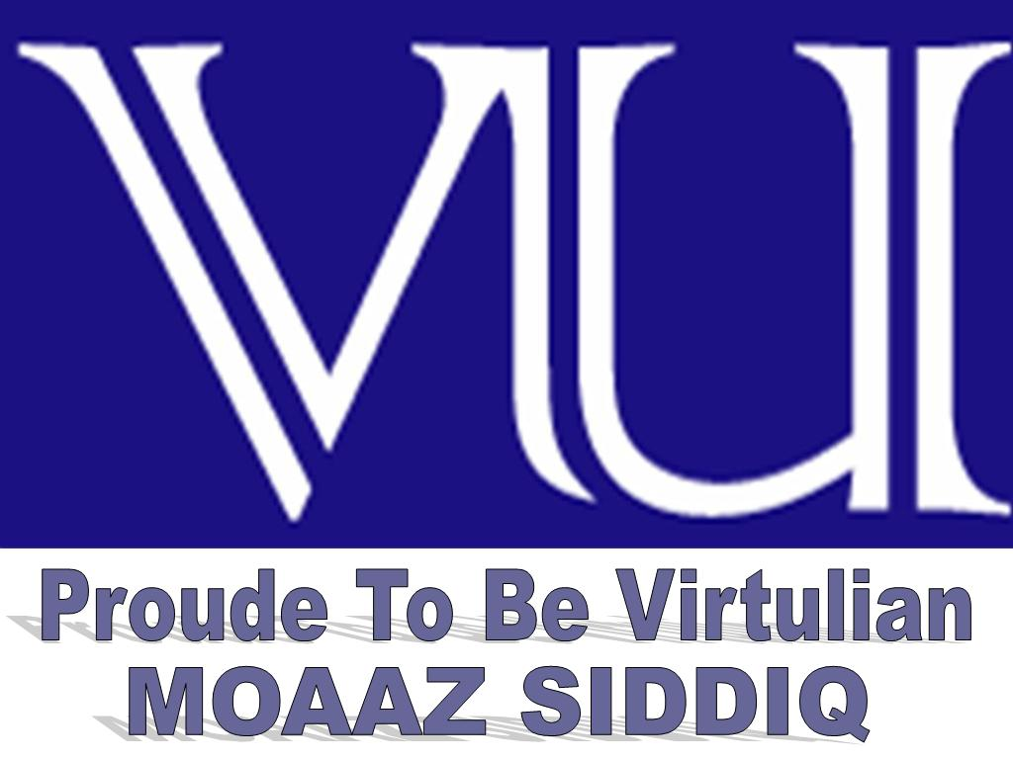 | CS605 – Soft Engendering II  Solved Subjective  From Midterm Papers | 1st DEC,2012
MC100401285 | Moaaz.pk@gmail.com Mc100401285@gmail.com | PSMD01
CS605 - Final Term Papers Fall 2012
characteristics of risk
Answer: - (Page 84)
A risk has two characteristics:
• Uncertainty – the risk may or may not happen
• Loss – if the risk becomes a reality, unwanted consequences or losses will occur.

types of reviews
Answer: - (Page 110)
There are many types of reviews. In general they can be categorized into two main categories namely informal and formal technical reviews.

when a system called legacy system
Answer: - (Page 134)
A system is considered to be a legacy system if it has been in operation for many years. A legacy system has many components. These include business processes, business rules, application software, application data, support software, and system hardware.

diff btw synchronous and open paradigm
Answer: - (Page 32)
• open paradigm—attempts to structure a team in a manner that achieves some of the controls associated with the closed paradigm but also much of the innovation that occurs when using the random paradigm
• synchronous paradigm—relies on the natural compartmentalization of a problem and organizes team members to work on pieces of the problem with little active communication among themselves

If SCM is not its proper place then what are disadvantages?
Answer: - (Page 119)
Software configuration management (SCM) is one of the five KPA required for an organization to be at CMM level 2. That means, according to SEI, effective project management is not possible without having a proper SCM function in place.
The basic idea behind SCM is to manage and control change. As mentioned by Bersoff, no matter where you are in the system life cycle, the system will change, and the desire to change it will persist throughout the life cycle. It is therefore essential that we manage and control it in a fashion that this continuous change does not convert into chaos.

requirement attributes
Answer: - (Page 127)
We need to tag requirements with certain attributes in order to manage them in an orderly fashion. Attributes are used to establish a context and background for each requirement. They go beyond the description of intended functionality. They can be used to filter, sort, or query to view selected subset of the requirements. A list of possible attributes is enumerated as below:
1. Requirement ID
2. Creation date
3. Created by
4. Last modified on
5. Last modified by
6. Version number
7. Status
8. Origin
9. Subsystem
10. Product Release
11. Priority

CS605 - Final Term Papers Fall 2012
2 Marks
Why in the software engineering measurements are collected?
Answer: (Page 65)
Because Measurement helps in identification of the problem as well as in determining the effectiveness of the remedy. A software engineers collects measures and develops metrics and indicators.

Fault tree can be used to predict the chain of events?
Answer: (Page 117)
Analysis techniques such as fault tree analysis can be used to predict the chain of events that can cause hazards and the probability that each of these events will occur to create the chain.

“Message chain” can be a bad smell in the coding justifies it with reason?
Answer: (Page 144)
A client asks an object for another object and then asks that object for another object etc. Bad because client depends on the structure of the navigation

CCB stands for what?
Answer: (Page 124)
CCB stands for Change Control Board
Marks 3…
Write down the guide line to make a review meeting success full?
Answer: (Page 113)
The followings are guide lines to make review meeting successful:
· Avoid drift
• Limit debate and rebuttal
• Enunciate problem areas but don’t try to solve all problems
• Take written notes
• Limit the number of participants and insist upon advanced preparation
• Develop a checklist for each product that is likely to be reviewed
• Allocate resources and schedule time for FTRs
• Conduct meaningful training for all reviewers
• Review your early reviews
• Determine what approach works best for you

What characteristics of extreme programming make it different to the other life cycle models?
Answer: (Page 23)
One very important feature of eXtreme programming is the concept of pair programming. In this, a team of two developers develop the software, working in team as a pair to the extent that they even share a single computer.

If the requirements are not traceable then what will be the impact on the requirement management?
Answer: (Page 133)
Requirement traceability is a very important consideration for requirement management. It is really hard to manage requirements that are not traceable.

Is this correct that in the Reverse engineering we move from lower abstraction to the higher abstraction level?
Answer: (Page 139)
Yes, Reverse engineering for software is a process for analyzing a program in an effort to create a representation of the program at a higher level of abstraction than the source code.
5 marks…
A technical review meeting is attended by the Review leader, the reviewer and the producer. Write the roll of producer and the reviewer in the meeting?
Answer: (Page 112)
The producer informs the PM that the WP is ready and the review is needed. Review meeting is attended by the review leader, all reviewers, and the producer. One of the reviewers takes the roles of recorder. Producer walks through the product, explaining the material while other reviewers raise issues based upon their advanced preparation.

Why the “Large classes” and “Duplicate code” are considered as bad smell give at least one reason for each?
Answer: (Page 143)
Large classes try to do too much, which reduces cohesion.
If you modify one instance of duplicated code but not the others, you (may) have introduced a bug!

We can ensure the 100% risk free software development process, can weguarantee that during the entire software development process there will b no occurrence of any risk. Comment with the reason?
Answer:- Click here for detail
Let’s be clear: there’s no such thing as risk free software. You can’t do anythingwithout taking some risk. But what’s easy to overlook, is that not doing something is a risk, too.
Not fixing a bug runs the risk that its more serious than you thought; more prevalent than you thought; that it could happen to an important customer, someone in the press, or a highly valued customer – with real revenue risk. You run the risk that it collides with another, as yet unknown bug, potentially multiplying the pain.
Sometimes not releasing feels like the safest thing to do – but you’re releasing software because you know something is wrong.
So what you gonna do? No business wants to accept risk, you have to mitigateit somehow. The simple, easy and wrong thing to do is to add more process. The braver decision, the right decision, is to make it easy to undo any mistakes.

Whenever change is required, CCB decide allow to happen or deny. If it is decided that change is necessary it is needed ECO engineer change order is generated. What types of information are depicted by ECO?
Answer: (Page 124)
An ECO defines the change to be made, the constraints that must be respected, and the criteria for review and audit. The change control process thus involves the following steps.
1) need for change is recognized
2) change request from user
3) developer evaluates
4) change report is generated
5) change control authority (CCA) decides
6) Either step 6a or 6b is performed. Steps numbers 7 to 17 are performed only if step 6b is performed.
a)
i) change request is denied
ii) user is informed
iii) no further action is taken.
b) assign people to SCIs
7) check-out SCIs
8) make the change
9) review/audit the change
10) check-in SCIs
11) establish a “baseline” for testing
12) perform SQA and testing activities
13) check-in the changed SCIs
14) promote SCI for inclusion in next release
15) rebuild appropriate version
16) review/audit the change
17) include all changes in release
Thus, a change is incorporated in a controlled and strict manner.

CS605 - Final Term Papers Fall 2012

1.Differentiate between fountain model and RUP. (2)
Answer: (Page 23)
Fountain model is another object-oriented lifecycle model. In this model the circles representing the various phases overlap, explicitly representing an overlap between activities.

In Rational Unified Process (RUP) model a software product is designed and built in a succession of incremental iterations. The process emphasizes that during development, all activities are performed in parallel, however, and at a given time one activity may have more emphasis than the other.
2.Formula for MTBF. (2)
Answer: (Page 116)
MTBF = MTTF + MTTR
3.A student claims that requirement errors are most common type of software errors and are most costly to fix. Do you agree? (2)
Answer: (Page 127)
Yes, Agree.
Project success depends on good requirement management. It may be recalled that requirement errors are the most common type of software development errors and the most costly to fix. It may also be recalled that requirement errors are listed as one of the roots causes of software project failure.
4.Which one is the ad hoc level? Level-1 or Level-2 or Level-3? (2)
Answer: (Page 12)
Level 1 – Initial is also called ad hoc level.
5.How defect removal efficiency can be increased by revision? Explain. (3)
Answer: (Page 68)
Defect removal efficiency is the measure of how many defects are removed by the quality assurance processes before the product is shipped for operation.

Factors related with revision
• Maintainability
– Effort required to locate and fix an error in a program
• Flexibility
– Effort required to modify an operational program
• Testability
– Effort required to test a program to ensure that it performs its intended function
6.State the advantages of waterfall model that are helpful for project managers. (3)
Answer: Click here for detail
Simple and easy to understand and use.
Easy to manage due to the rigidity of the model – each phase has specific deliverables and a review process.
Phases are processed and completed one at a time.
Works well for smaller projects where requirements are very well understood.
7. Write down the format of the compound number normally used for release versioning (3)
Answer: (Page 122)
Although there is no industry standard, typically, a three field compound number of the format “X.Y.Z” is used. The different fields communicate functionality information about the product release.
The first digit, X, is used for the major release number which is used to identify a major increase in the product functionality.
The second digit, Y, stands for feature release number. The feature release number is iterated to identify when a set of product features have been added or significantly modified from their originally documented behavior.
The third digit, Z, is called the defect repair number and is incremented when a set of defects is repaired.
8.Differentiate between organizational maturity and process capability. (3)
Answer: (Page 170)
Organizational maturity is the focus of the staged representation, whereas process area capability is the focus of the continuous representation.
Organizational maturity and process area capability are similar concepts. The difference between them is that organizational maturity pertains to a set of process areas across an organization, while process area capability deals with a set of processes relating to a single process area or specific practice.
9.What does the producers and the reviewer play in reviwe meetings? (5)
Answer: Rep
10.Ina human resource application, information of an elmployee is added by entring some general information. In addition to general informations, the employee is salaried or hourly employee. The user has determined that an employee must be either salatied or hourly. Either type have informatins about dependencies. dentify the RET in above situation. (5)
Answer: (Page 46)
For this example, there are
three subgroups or RETs as shown below:
· Salaried employee (mandatory); includes general information
· Hourly employee (mandatory); includes general information
· Dependent (optional)

11.a chat messenger is realeased and its version is 1.0.0 .it only posses chat functionality now. after 1 year there are different major features are added lilke audio/video calls, files sharing and data sharing. now what version number this chat messenger posses? (5)
Answer: (Page 122)
After 1 year version number will 2.0.0
Conventionally, a release number starts with a major number of one, followed by zero for its feature and maintenance numbers. This results in a release number 1.0.0. The first digit, X, is used for the major release number which is used to identify a major increase in the product functionality. The major release number is usually incremented to indicate a significant change in the product functionality or a new product base-line.

CS605 - Final Term Papers Fall 2012
Q. Two parameter of legacy system? (2marks)
Answer: - (Page 135)
A legacy system can be accessed from two different perspectives – business value and quality.
Q. Forward and reverse engineering?(2marks)
Answer: - (Page 139)
Reverse engineering for software is a process for analyzing a program in an effort to create a representation of the program at a higher level of abstraction than the source code
Forward engineering requires application of SE principles, methods, and concepts to re-create an existing application.
Q. Two characteristics of risk? (2marks)
Answer: - Rep

Q. Do u think that a long parameter list of functn /method can b bad smell? (3 Marks)
Answer: - (Page 143)
Long Method
– Long methods are more difficult to understand; performance concerns with respect to lots of short methods are largely obsolete.

Long Parameter List
– hard to understand, can become inconsistent
Q. Format the compound No. (3 Marks)
Answer: - Rep
Q. Occurrence of a software does not necessary result in a hazard or mishap do u agre or not (3 marks)
Answer: - (Page 117)
Yes, agree.
Reliability and safety are closely related. Software reliability uses statistical techniques to determine the likelihood that a software failure will occur. Occurrence of a software failure does not necessarily result in a hazard or mishap. On the other hand, software safety examines the ways in which failures result in conditions that can lead to a mishap.

CS605 - Final Term Papers Fall 2012

Short Questions - 2 Marks

1. “Message Chain” can be a bad smell. Explain it.
Answer: - Rep

2. A student claims that requirement errors are most common type of software errors and are most costly to fix. Do you agree?
Answer: - Rep

3. Is it true Poka-Yoke technique deals with project planning?
Answer: - (Page 118)
Poka-yoke is a Quality Assurance and Documentation technique. Poka-yoke devices are mechanisms that lead to prevention of potential quality problem before it occurs or the rapid detection of quality problems if they are introduced.

4. Write down 2 quality factors related with revision phase of software.
Answer: - Rep

Short Questions - 3 Marks
1. In reverse engineering we move from lower abstraction level to higher level. Yes or no
Answer: - Rep

2. What are the appropriate situations to scrap a legacy system? (3)
Answer: - (Page 135)
This is the case when system is not making an effective contribution to business processes and business processes have changed significantly and the organization is no longer completely dependent upon the system.

3. What is effort validation?
Answer:- (Page 93)
Every project has a defined number of staff members. As time allocation occurs, the project manager must ensure that no more than the allocated number of people has been scheduled at any given time.

4. Write down the guidelines to make a review meeting successful.
Answer: - Rep

Long Questions – 5 Marks
1. As compared to other models, waterfall mode is more manageable for managers. Explain with reasons.
Answer: - Rep

2. Do you think it is difficult to implement CMM level in small software companies?

3. Many times we tag requirements with certain attributes e.g., Requirement ID, requirement Status, list any two advantages of such tags.
Answer:- (Page 128)
Attributes are used to establish a context and background for each requirement. They go beyond the description of intended functionality. They can be used to filter, sort, or query to view selected subset of the requirements.

4. Mention two problems that can be faced by software development organization if they are not having SCM.
Answer: - Rep

CS605 - Final Term Papers Spring 2012

1 Difference between measure and matrix
Answer:- (Page 65)
Within the software engineering domain, a measure provides a quantitative value of some attribute of a process or a product.
Software metric relates individual software measures to provide a normalized view.
2 write three EI's counting rules
5 In technical review meeting write the role of the producer and reviewers
Answer: - Rep
6 CCB stands for?
Answer: - Rep
7 Keeping in mind CMM maturity level find where the ad-hoc level falls
Answer: - Rep
8 Comments can be bad smell? write a reason
Answer: - Rep

9 Write four reasons to migrate the legacy system
Answer:- (Page 135)
1. Scrap the system completely: This is the case when system is not making an effective contribution to business processes and business processes have changed significantly and the organization is no longer completely dependent upon the system.
2. Continue maintaining the system: This option is used when system is still required, it is stable, and requirements are not changing frequently
3. Transform the system in some way to improve its maintainability: this option is exercised when system quality has been degraded and regular changes to the system are required.
4. Replace the system with a new system: this path is taken when old system cannot continue in operation and off-the shelf alternative is available or system can be developed at a reasonable cost.

CS605 - Final Term Papers Spring 2012

4 questions of 2 marks each.
1 which is individual level in CMM?
Answer:- (Page 12)
level 1

2 what is SCI in respect to SCM?
Answer:- (Page 120)
A Software Configuration Item (SCI) is the information that is created as part of the software engineering process.

3 "baseline requirements affects to trace" is it true or false? true.

4 massage chain is why add towards bad smell?
Answer: - Rep

3 marks questions were
1 what is release version number format?
Answer: - Rep

2 what is software reliability?
Answer:- (Page 115)
Software reliability is another very important quality factor and is defined as probability of failure free operation of a computer program in a specified environment for a specified time. For example, a program X can be estimated to have a reliability of 0.96 over 8 elapsed hours.

3 RMMM what defines?
Answer:- (Page 88)
RMMM stands for risk mitigation, monitoring, and management plan.

5 marks questions

2: a chat messenger is realeased and its version is 1.0.0 .it only posses chat functionality now. after 1 year there are different major features are added lilke audio/video calls, files sharing and data sharing. now what version number this chat messenger posses?
Answer: - Rep

3: why prototyping is applied in business process model?

4: the SQA techniques are well or not for the development of software systems? give your comments to prove either right or wrong?
Answer:- (Page 108)
An SQA plan is developed for the project during project planning and is reviewed by all stake holders. The plan includes the identification of:
• Evaluations to be performed
• Audits and reviewed to be performed
• Standards that are applicable to the project
• Procedures for error reporting and tracking
• Documents to be produced by the SQA group
• Amount of feedback provided to the software project team
The group participates in the development of the project’s software process description. The software team selects the process and SQA group reviews the process description for compliance with the organizational policies, internal software standards, externally imposed standards, and other parts of the software project plan.

CS605 - Final Term Papers Spring 2012

1. Which process model is best for the development of all kinds of software? 2 marks

2. two types of reviews ? 2 marks
Answer: - Rep

3. When a system is called a Legacy System? 2 marks
Answer: - Rep

4. Advantage of re engineering in Legacy system? 2 marks

5. How deadline of a product influence quality and resources of product? 3 marks
Answer:- (Page 27)
Delivery deadline directly influences the resources and quality. With a realistic deadline, chances of delivering the product with high quality and reasonable resources increase tremendously as compared to an unrealistic deadline. So a project manager has to first determine a realistic and reasonable deadline and then monitor the project progress and ensure timely delivery.

6. Software configuration management is a design activity Give your answer yes or no. support your answer with reason. 3 marks

7. What is the potential benefit of modifying the source code and data ? 3 marks
Answer:- (Page 139)
We modify source code and data in order to make it amenable to future changes. This includes code as well as data restructuring. Code restructuring requires redesign with same function with higher quality than original program and data restructuring involves restructuring the database or the database schema. It may also involve code restructuring.

8. MTTF = 48, MTTR = 4, calculate availability? 5 marks
Answer:-
MTBF = MTTF + MTTR
= 48+4 =52

Availability = (MTTF/MTBF) x 100
= (48/52) x 100 = 92.30

9. List the Steps of software re engineering? 5 marks
Answer:- (Page 138)
Inventory analysis
Document restructuring
Reverse engineering
Program Restructuring
Data restructuring
Forward Engineering

11. Interdependency of each compartmentalized step is necessary? What is the effect of interdependency on the overall project? 5 marks
Answer:- (Page 92)
The interdependency of each compartmentalized activity or task must be determined. Some tasks must occur in sequence while others can occur in parallel. Some activities cannot commence until the work product produced by another is available.

CS605 - Final Term Papers Spring 2012

1. Do u think that it is difficult to implement CMM levels in small software companies? (5)
Answer: - Rep

2. Many time we tag requirements with certain attributes e.g, Requirement ID, requirement Status, list any two advantages of such tags (5).
Answer: - Rep

3. The relationship between number of people and time to develop an application is not linear, what do you understand by this statement? (5)
Answer:- (Page 92)
The relationship between the number of people and time to develop an application is not linear. It is not as simple as a 120 man-day project can be developed by 1 person working for 120 days or 120 people working for 1 day. The communication and coordination overhead plays a very significant role.

4. Comment on the following statement regarding "review meeting" No review is better than an un-controlled review? (5)
Answer:- (Page 113)
An uncontrolled review can be worse than no review. The basis principle is that the review should focus on the product and not the producer so that it does not become personal. Remember to be sensitive to personal egos. Errors should be pointed out gently and the tone should be loose and constructive.

5. Do you think that a long parameter list of a function/method can be a 'bad smell', give reasons to support your answer? (3)
Answer:- (Page 143)
Long Parameter List hard to understand, can become inconsistent

6. Write down the format of the compound number normally used for release versioning (3)
Answer: - Rep

7. Why is the system being developed in W5HH principle, Explain. (3)
Answer: -
The answer to this question all parties to the validity of the business reasons for the software to evaluate. Set in a different way; time not only business people and spending money?

8. How defect removal efficiency can be increased with the help of reviews (3)
Answer: - Rep

9. During forward engineering we can not add new business processes and rules in the system, Do u agree? (2)

10. CCB stands for (2)
Answer: - Rep

11. What issues must be included in the review list? (2)

CS605 - Final Term Papers Fall 2011

Two Factor of Revision ( 2 )
Answer: - Rep
How can calculate MTBF ( 2 )
Answer: - Rep
what is software refactoring ( 2 )
Answer:- (Page 143)
Software refactoring is the process of changing a software system such that the external behavior of the system does not change while the internal structure of the system is improved. This is sometimes called “Improving the design after it has been written”.

List the factor involved in calculating the cost of reengineering ( 3 marks )
Answer:- (Page 140)
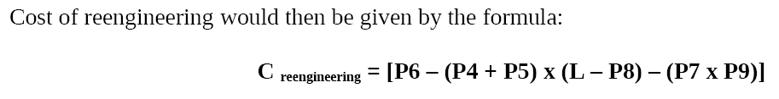

The following code segment sorts an array of integers using “selection sort” algorithm. ( 3 marks )
for (i=0; i < N-1; i++) {
min = i;
for (j = i; j < N; j++)
if (a[j] < a[min]) min = j;
temp = a[i];
a[i] = a[min];
a[min] = temp;
Answer:- (Page 144)
We break it into smaller fragments by making smaller functions out of different steps in
the algorithm as follows:
int minimum (int a[ ], int from, int to)
{
int min = from;
for (int i = from; i <= to; i++)
if (a[i] < a[min]) min = i;
return min;
}

void swap (int &x, int &y)
{
int temp = x;
x = y;
y = temp;
}

The sort function now becomes simpler as shown below.
for (i=0; i < N-1; i++) {
min = minimum (a, i, N-1);
swap(a[i], a[min]);
}

what are the step of BPR ( 5 marks )
Answer:- (Page 141)
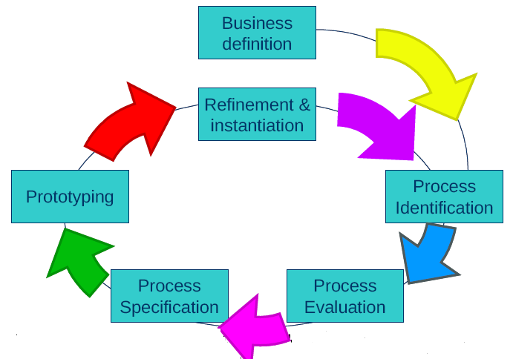

CS605 - Final Term Papers Fall 2011

MY LAST PAPER OF CS 506 ON 16 FEB 2012
How to remove temporary variable , which is causing problem- 2 marks
what is 90-10% rule - 2 marks
What is the requirement of waterfall method- 2 marks
Check in and Check out
Forward and Rear word engineering
Problems are amplified if defects not discovered in early stage . comment
what is meant by following code-- code segment for selection sort
Write down parameters of cost of engineering
write down five bad smells
hazards for cruise control automobile system
discuss defect removal effeciency
what is process of change control in SCM

CS605 - Final Term Papers Fall 2011

Difference between Fountain model and RUP model 2 marks
Two characteristics of level 1 CMM. 2 marks
Defect removal efficiency formula 2 marks
Software reliability definition 2 marks
Forward engineering. 2 marks

How application software in legacy system can be accessed? 3 marks
Can Poka Yoke be useful in planning phase 3 marks
What is CSR and its working? 3 marks
How deadline of a product influence quality and resources of product ? 3 marks
Is software failure is a hazard? What do you think? 3 marks

If MTTF = 48, MTTR = 4, Calculate availability? 5 marks
Suppose you have to develop LMS as a project manager so what type of technical risk would be there? 5 Marks
Is CMM is difficult to adopt for small software companies? 5 marks
Four strategic option for assessing legacy system assessment? 5 marks

CS605 - Final Term Papers Fall 2011

my ppr
q.what must be included in software tracking
q.difference in business process reengineering model and software reenginering model
q.how cost of reengineering is calculated
q.what is software refactoring
q.what are the risks in legacy system migration
q.reviews
q.status meetings
q.time boxing
q.80-20 rule

CS605 - Final Term Papers Fall 2011

my cs605 Today paper
difference b/w farward engineering and reverse engineering
difference b/w proactive and reactive risk management
three characteristics of Poka- Yoki
SQA group authority
difference b/w CCA and CCb.
advantages of cmm
what is capability level
statistical measurment of availability
must prepare lec 12 to 22 most of short question and MCQs are from these lectures.

CS605 - Final Term Papers Fall 2011

40 mcqs..
buhat togh thay past me se nahi thay sab new and confusing
5 question of 2 marks.
1) what is software refactoring
2)what is software safety
3)difference between DD& CD.
4)uses of time boxing
5)difference btween check-in and check-out processes
5 question of 3 marks.
1) what should be included in software tracking methods
2) hazards associated with the computer based cruise of an automobile
3)code tha selection sort ka uska batana tha
4)waterfall 's major drwaback is it may not fullfill client's requirements. in ur opinion ahich model handles this shortcuming
5)working of check-in and check-out processes
3 question of \5 marks.
1) risks involve in migration of legacy systems
2) problem can be cuased by the following bad smells
large classes
shortgun surgery
3) what is the advantage of having consistency in work product.

CS605 - Final Term Papers Fall 2011

40 MCQs
2 Marks
Earned value analysis
Five software delivery problem
How much time frame we can use in Rapid Application Development (RAD)?
Differentiate between Check-in and Check-out processes.
3 Marks
How can we increment the task associated with time-box?
What should this model depict?
Give the code functionality of given code.
Class PriceÖ
double charge(int daysRented) { double result = 0;
switch (priceCode()) {
case Movie.REGULAR:
result += 2;
if (daysRented > 2)
result += (daysRented - 2) * 1.5;
break;
case Movie.NEW_RELEASE:
result += daysRented * 3;
break;
case Movie.CHILDRENS:
result += 1.5;
if (daysRented > 3)
result += (daysRented - 3) * 1.5;
break;
}
return result;
}
What basis Legacy system maintains or discards?
5 Marks
How can 80-20 rule apply while business process re-engineering?
Give suggestions to make Walkthrough to be effective.

